MANUAL – PROCUREMENT
① PURCHASE REQUEST
➡️ This section allows the creation of Purchase Requests based on the approved Consolidated PPMP, ensuring that all requested items align with the planned and approved procurement requirements.

➤ Create New Purchase Request
Step 1. Navigate the Page to Purchase Request → Create PR
Step 2. Complete the required input fields.
Input fields:
- Items for Procurement – Basis for the items to be procured.
- Year of the Selected Type – Calendar year associated with the selected procurement type.
- Enter Transaction Code – Transaction code of the Consolidated or Emergency PPMP.
- Milestone – Target timeframe for purchasing the Consolidated or Emergency PPMP.
- Mode of Procurement – Method by which the items will be procured.
- Check Account Classification – Select all account classifications to be included in the purchase request.
Note:
If the checkbox on yellow background is checked, this will generate the quantities of the particulars based on the final adjustment.
If left unchecked, this will generate the quantities of the particulars based on the initial adjustment.
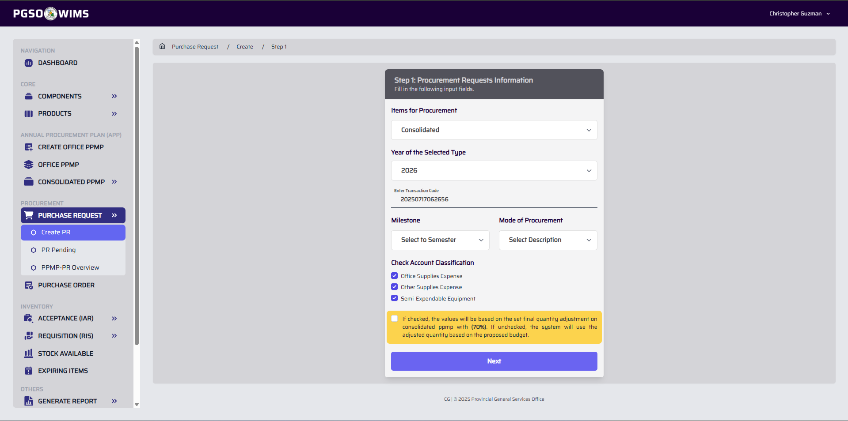
Step 3. Click Next. This will redirect you to the Form 2.
Step 4. Select all particulars to be included in the created Purchase Request.
Tips:
If most particulars are to be added to the PR, select the All checkbox in the table header to mark all entries at once. You may then deselect any unwanted particulars. This approach helps reduce time spent selecting individual items.

Sample PR Form 2
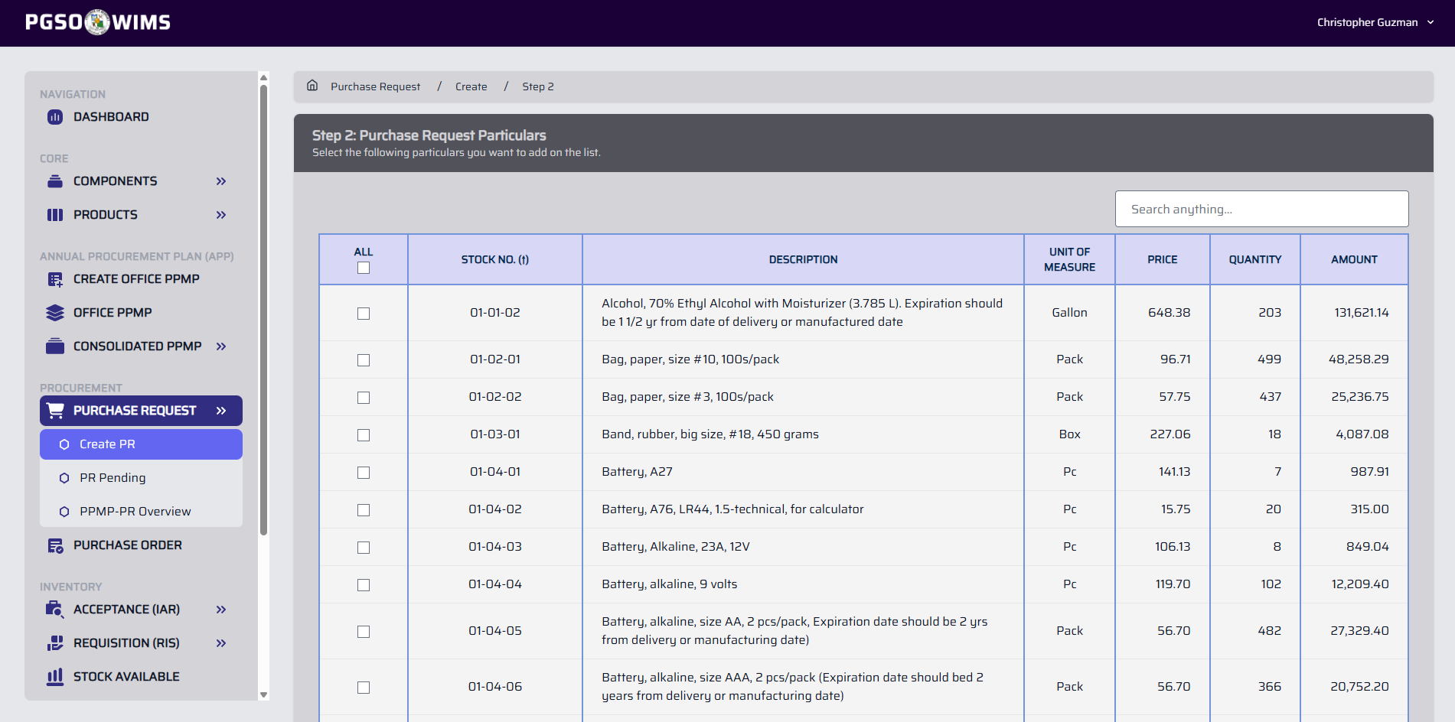
Step 5. Click ‘Submit’ button to proceed.
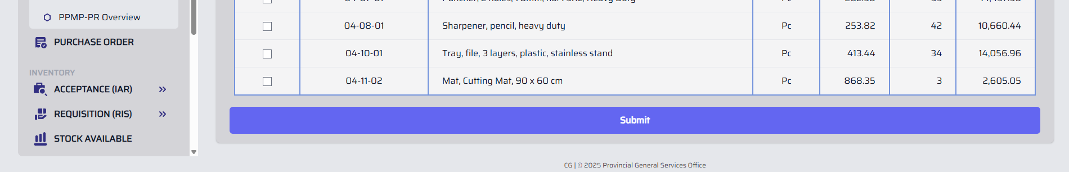

➤ View All Pending Purchase Request
Step 1. Navigate the Page to Purchase Request → PR Pending
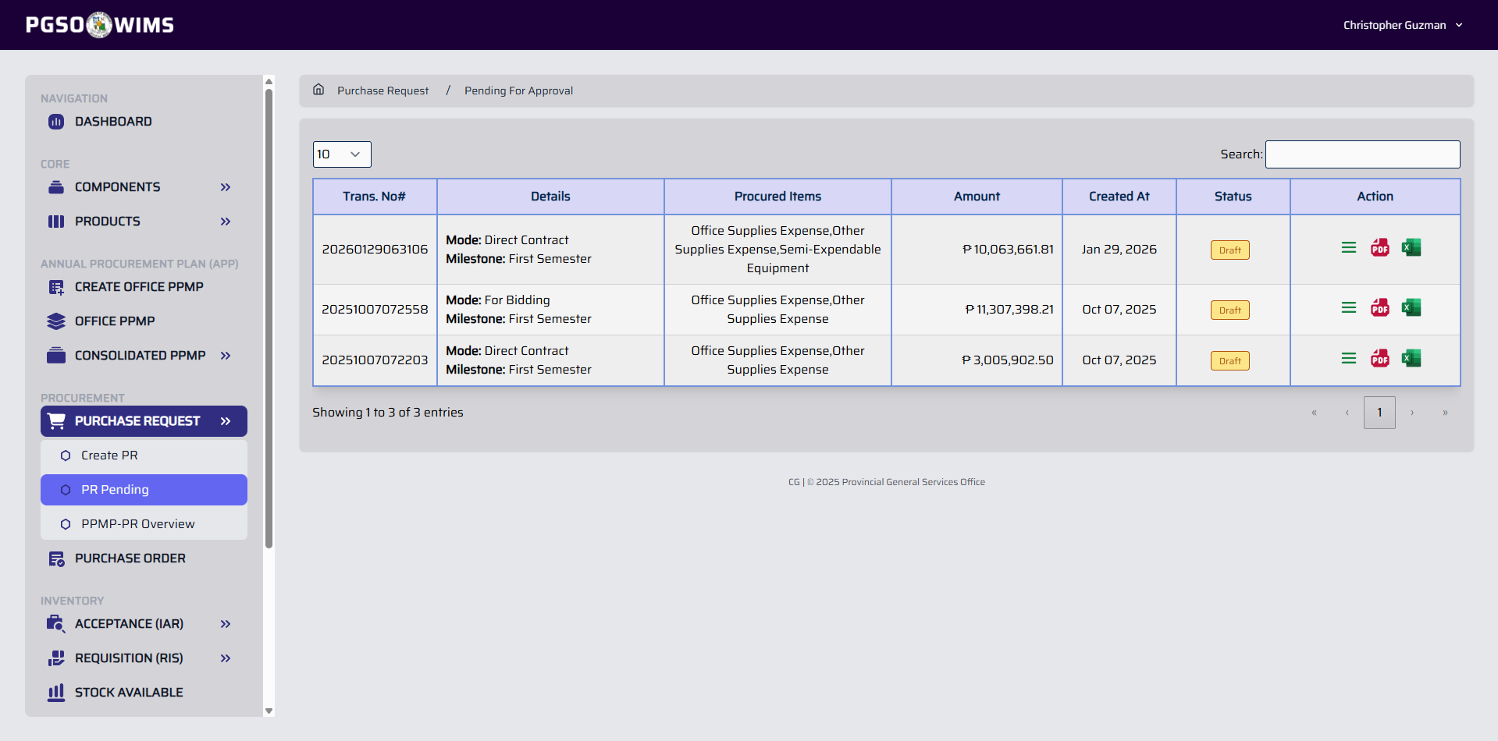
Click on the PDF icon or Excel Icon to generate a downloadable copy of a Purchase Request.

➤ View Purchase Request Transaction
Step 1. In PR Pending, click the View button icon in the Action column corresponding to the PR transaction.
Sample Output
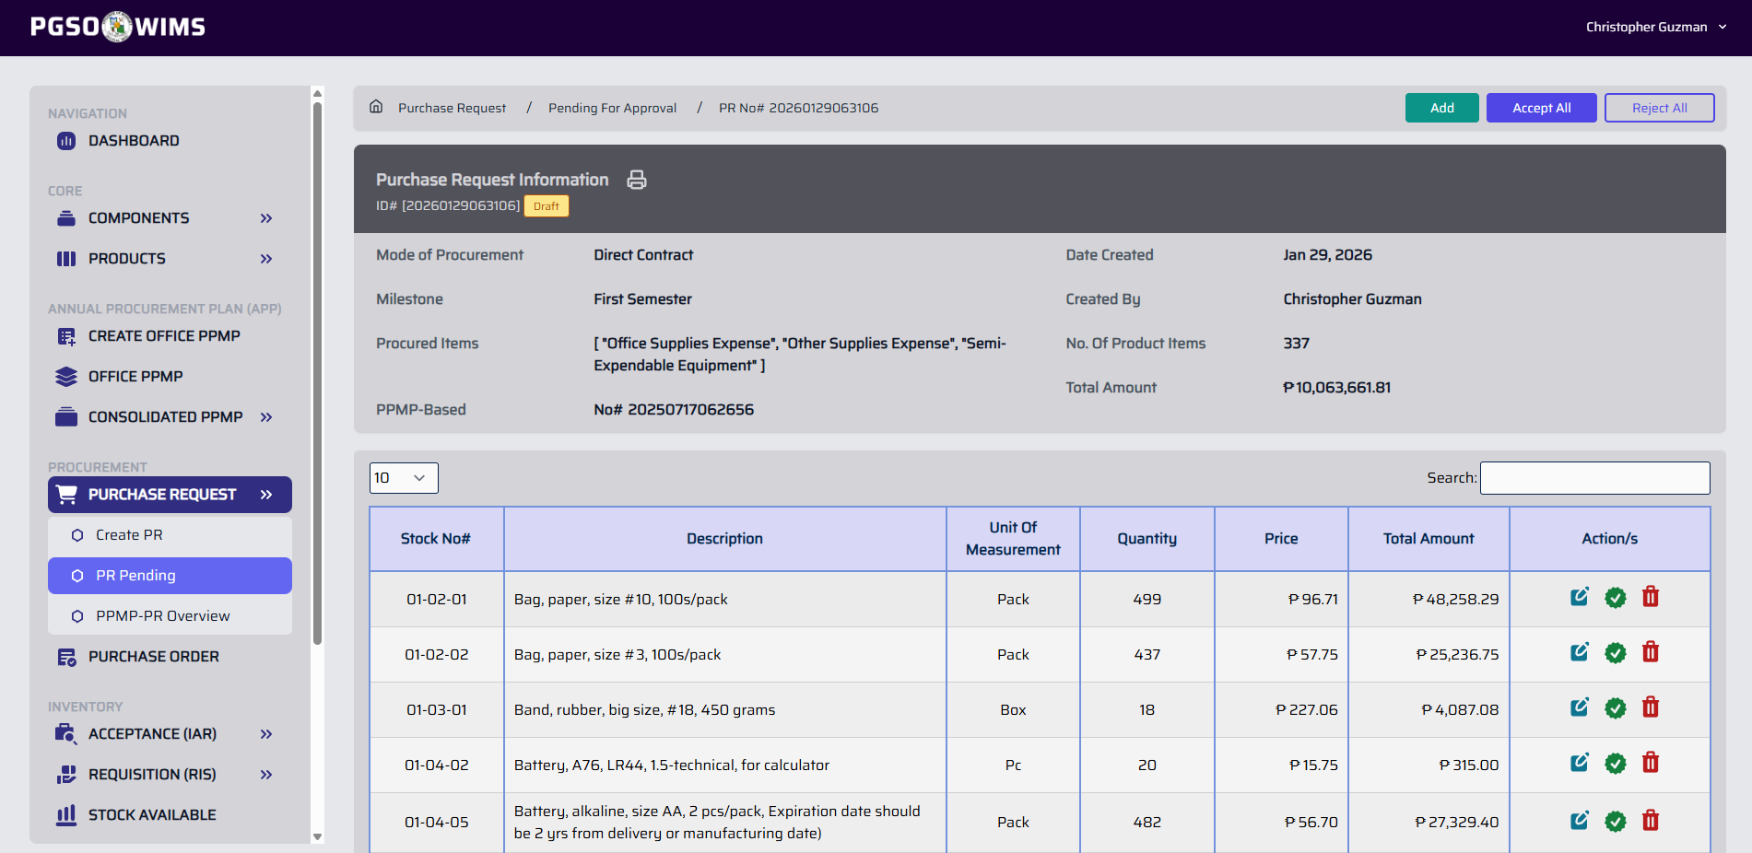
This shows the Summary Overview of the Purchase Request and its particulars. Particulars not qualified for a Purchase Order must be rejected to reset quantities in the Consolidated PPMP

➤ Add Particular on a PR Transaction
Step 1. Inside of a PR Transaction, click on the Add button to display a form.
Step 2. Complete the input fields. (Enter the complete Stock No. of the item)
Step 3. Click Confirm button to proceed.
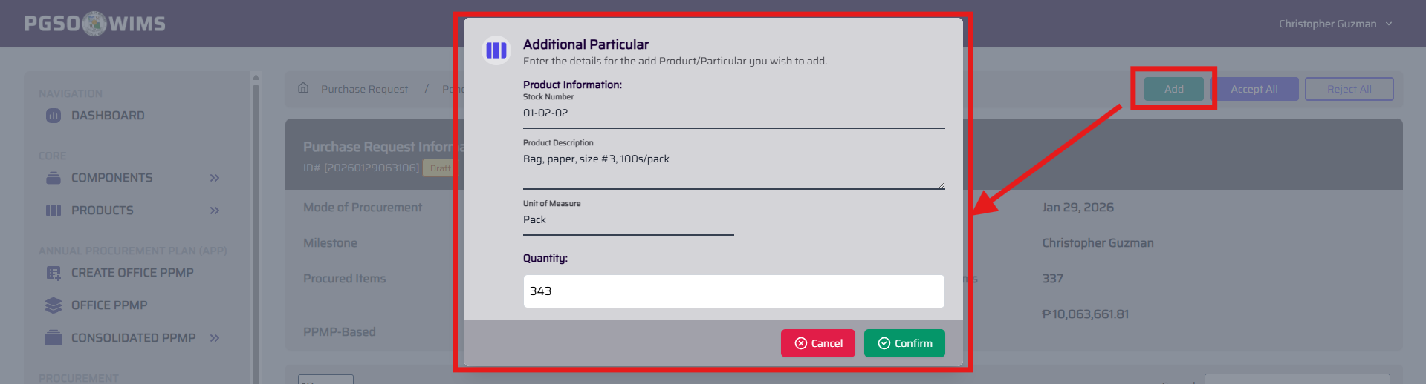

➤ Edit/Update Particular on a PR Transaction
Step 1. Inside of a PR Transaction, on the Particular table. Click on the Edit Icon button to display a form.

Step 2. Edit the details on the input fields. Editable fields are Description, Unit, Price and Quantity of the particular.
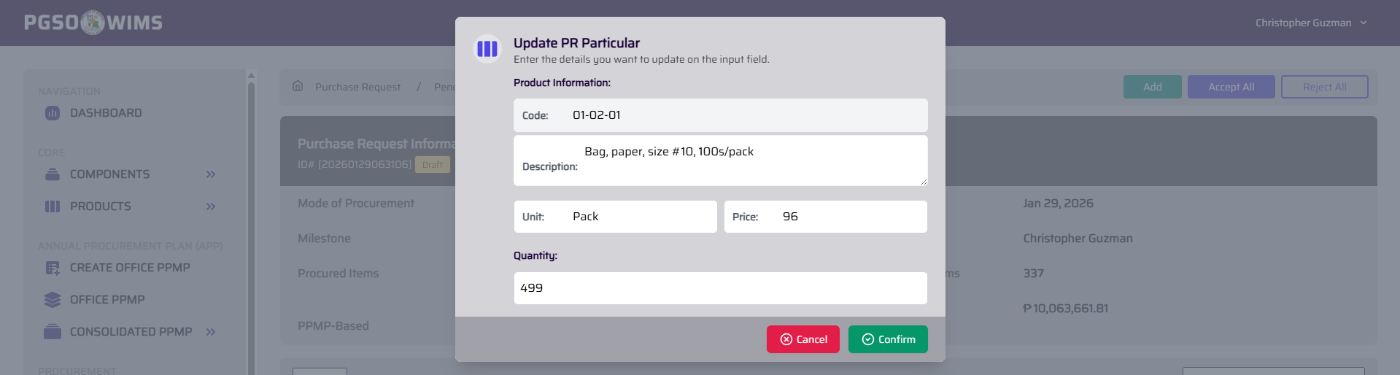
Updating the description of the Particular on PR will not affect the description of the Item in the Item List.
Step 3. Click Confirm button to proceed.

➤ Approved Particular on a PR Transaction
➡️ This action will move the selected particular to the Purchase Order process.
Step 1. Inside of a PR Transaction, on the Particular table. Click on the Approve Icon button to display a confirmation.
Step 2. Click Confirm button to proceed.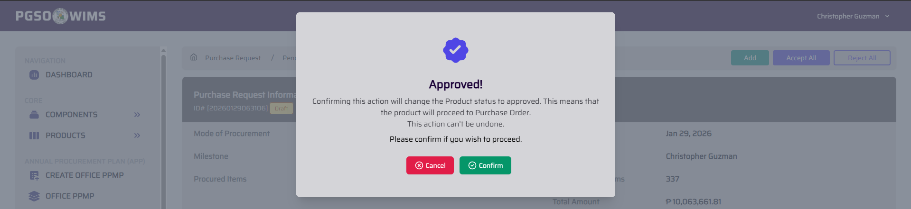

➤ Delete/Trash Particular on a PR Transaction
➡️ This action will move the selected particular to trash.
Step 1. Inside of a PR Transaction, on the Particular table. Click on the Trash Icon button to display a confirmation.
Step 2. Click Confirm button to proceed.
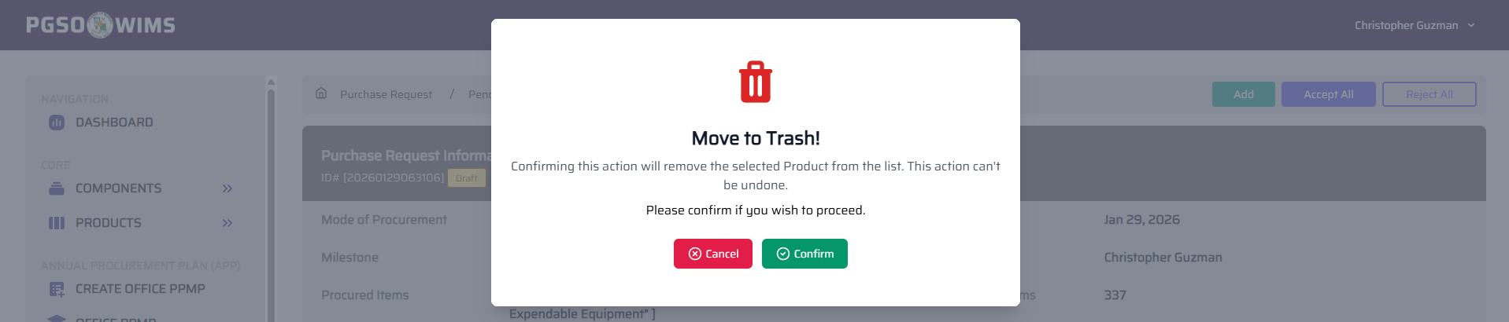

➤ Approved All Particular on a PR Transaction
➡️ This action will move all the particular within the PR Transaction to the Purchase Order process.
Step 1. Inside of a PR Transaction, on the Particular table. Click on the Accept All button to display a confirmation.
Step 2. Click Confirm button to proceed.
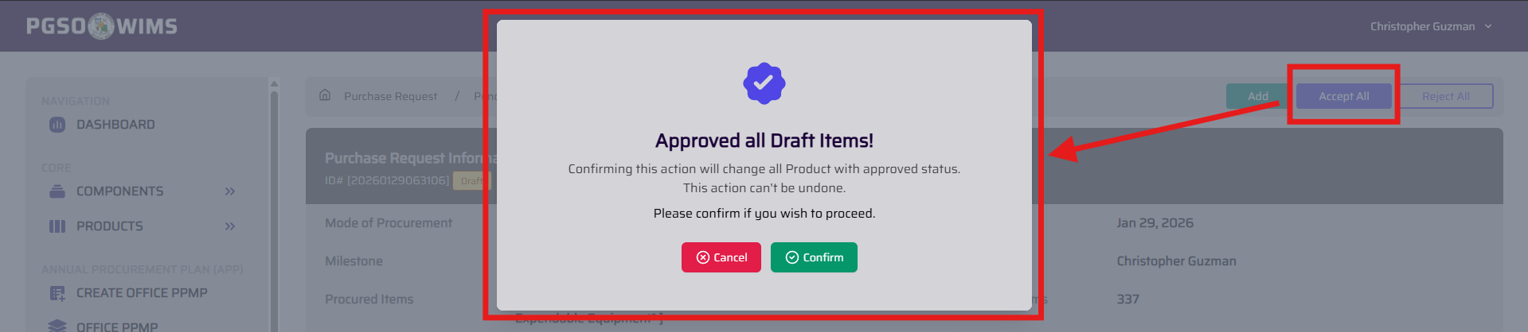
➤ Reject All Particular on a PR Transaction
➡️ This action will move all the particular within the PR Transaction to trash.
Step 1. Inside of a PR Transaction, on the Particular table. Click on the Reject All button to display a confirmation.
Step 2. Click Confirm button to proceed.
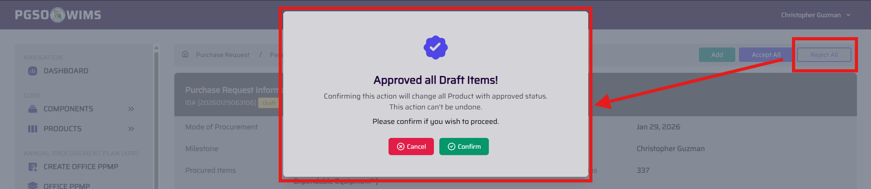
You may also generate a downloadable copy of the Purchase Request transaction directly from the PR Transaction page by clicking the Print icon (refer to the image below)
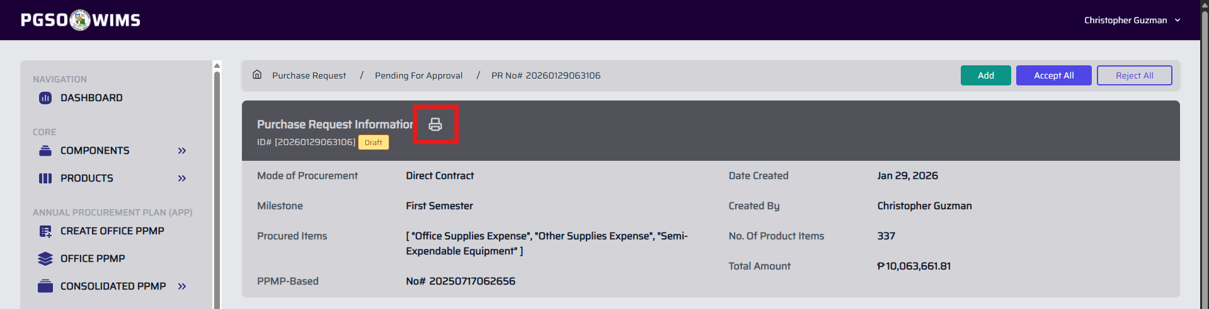
➤ PPMP Procurement Status Monitoring
➡️ This feature shows all Consolidated PPMPs containing one or more Purchase Requests made under the consolidated plan.
Step 1. Navigate the Page to Purchase Request → PPMP-PR Overview

Sample PPMP-PR Overview Page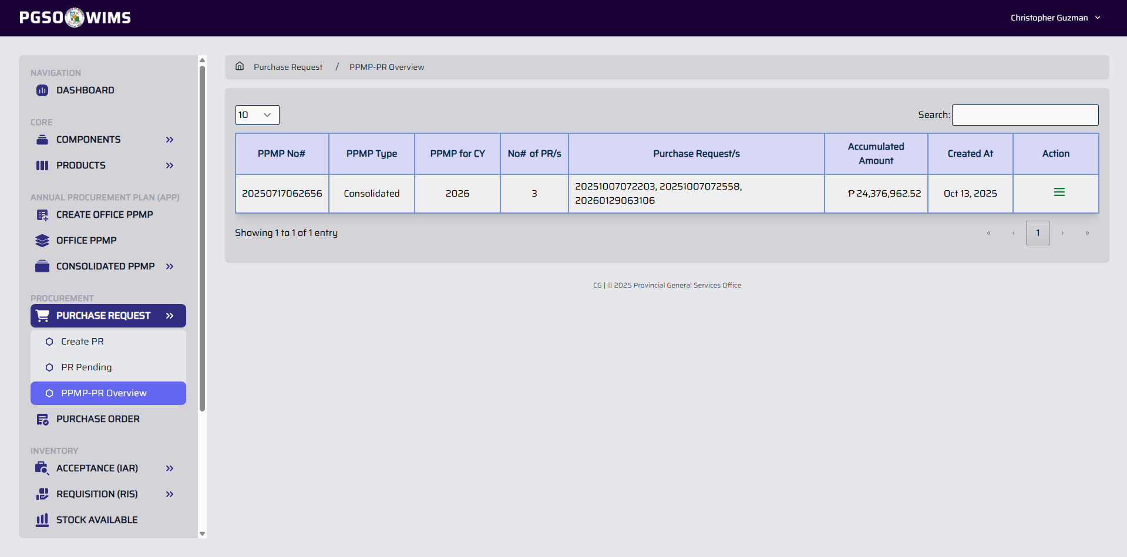

# View PPMP Transaction on PPMP-PR Overview
Step 1. On the table of the PPMP-PR Overview. Click on the View Icon button.
Clicking the View icon opens a page showing an overview of the PPMP, including the number of Purchase Requests, their transaction numbers, and the total amount. Procured and unprocured items are also displayed, with unprocured items highlighted in red.
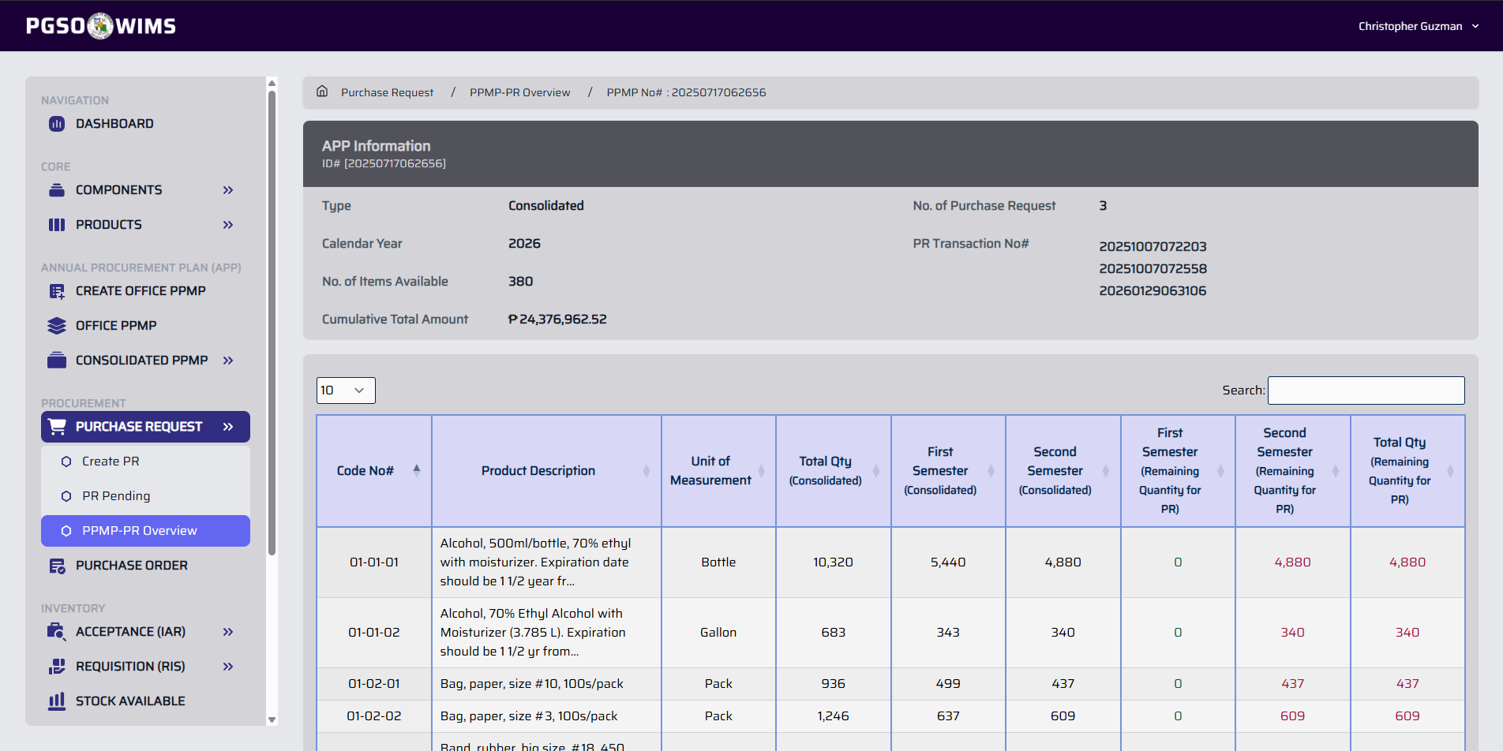

② PURCHASE ORDER
➡️ This module is on hold.

